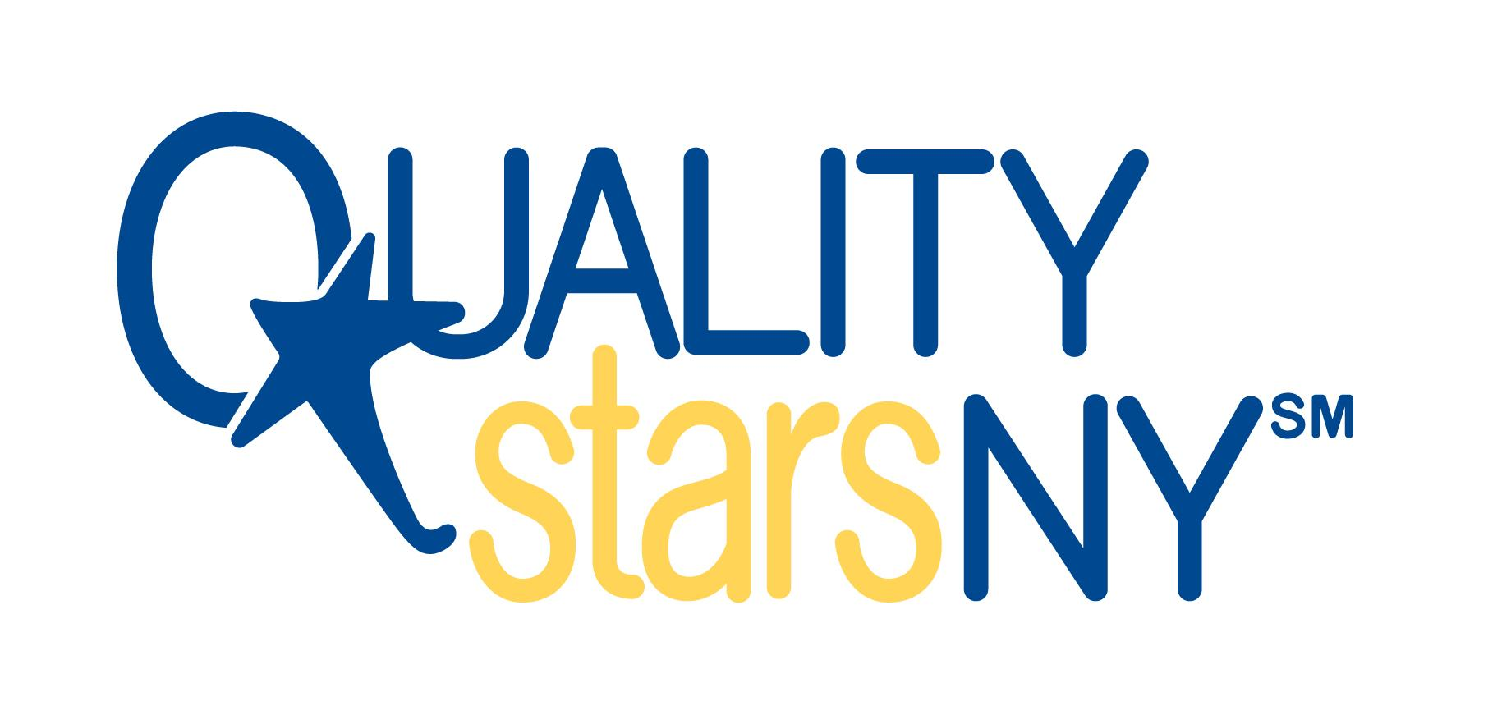 **ASA2: PAS Quality Improvement Plan Action Plan**

**Program Name: _________________________ Date PAS Completed:___________________**

**Directions: Review your PAS self-assessment scores. To meet Standard ASA2, evidence MUST reference ALL of the following:**

* **A detailed written plan based on results of the program management self-assessment tool submitted in ASA1.**
* **Plan MUST outline at least 3 indicators in need of improvement.**
* **Plan MUST outline concrete steps taken to achieve improvement for at least 3 indicators.**

|  |  |  |  |  |  |  |
| --- | --- | --- | --- | --- | --- | --- |
| **Goal with item number and indicator(s)** | **Action Steps** | **Person Responsible** | **Time needed to complete goal** | **Resources needed (training, ITA, materials, funding)** | **Projected completion date, mark when complete** | **Notes** |
| Example: Provide all staff with 6 days of paid sick time per year.  Item 5, 3.2 | *Ask board for permission to provide this benefit  *Create policy and have board approve  *Put policy in staff handbook  *Inform staff of new policy | *Director | -1 hr: draft presentation to board  -2 hrs: attend board mtg  -2 hours to create policy  -1 hour ITA to draft policy  -1 hour to attend board meeting for approval  -1 hr: put in staff handbook and inform them of new policy | ITA on drafting the policy | Projected completion date: November 15, 2023 | Met with the board on September 1, 2023, they have decided this is a benefit they can provide to staff. They want a draft policy by next board meeting on 10/1/23. |
| Goal 1: |  |  |  |  |  |  |
| Goal 2: |  |  |  |  |  |  |
| Goal 3: |  |  |  |  |  |  |